


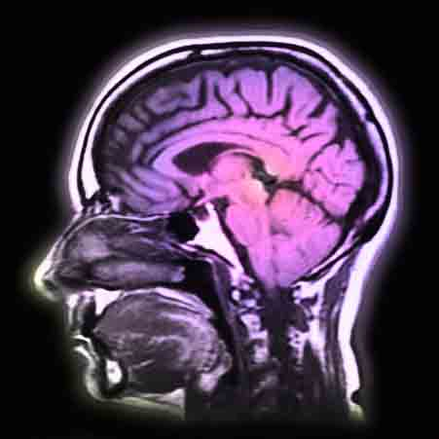
Who are we?
- We are researchers in audiology and brain imaging.
- We work at the UCL Institute of Child Health and Great Ormond Street Hospital in London.

Who are we looking for?
- Children age 8 years or older who have auditory neuropathy spectrum disorder (sometimes called auditory neuropathy or auditory dys-synchrony) who don’t have a cochlear implant.

What are we trying to find out?
- Whether children with audiotory neuropathy spectrum disorder have different brain structures to children without the condition.

What’s involved?
- Hearing testing, most of which will have been done before. This will last half a day.
- An MRI brain scan. This will last 35 minutes.
- You will get a picture of your brain if you like.

How will the results of this research be used?
- We will share our results with parents, professionals and other researchers.
- We will know if children with auditory neuropathy spectrum disorder have different brain structures to children without the condition.
- We will find out how differences in brain structures affect children with auditory neuropathy spectrum disorder.

What else do I need to know?
- We will always keep your results confidential and respect your needs.
- The National Institute for Health Research gave us the money to do this project.

Interested in finding out more or want to take part?
- Contact Hannah Cooper
- Email: Hannah.cooper.12@ucl.ac.uk
- Call: 020 7905 2300

